**PO2_DGW_Digital watch**

**(GDD)**

Table 1 Status Table

|  |  |  |  |  |
| --- | --- | --- | --- | --- |
| **Document Name** | **Author** | **Version** | **Update Date** | **Status** |
| GDD | Abdollah, Saher, Rasha, Yousef, Maghraby, Samira, Samuel | 1.1 | 17/03/2023 | Released |

**DOCUMENT HISTORY**

Table 2 Document History

|  |  |  |  |  |
| --- | --- | --- | --- | --- |
| **Version** | **Description of Change** | **Author** | **Date** | **Document Status** |
| 1 | Initial creation of GDD Document | Abdollah Mahmoud | 01/03/2023 | Draft |
| 1.1 | Adding Software input output,  Updating Software feature diagram and updating static layered architecture | Abdollah, Saher, Rasha, Yousef, Maghraby, Samira, Samuel | 01/03/2023 | Proposed |
| 1.1 | Updated the Descriptions of the return parameters in all requirements  Added Table of contents/List of Figures | Abdollah, Saher, Rasha, Yousef, Maghraby, Samira, Samuel | 17/03/2023 | Released |

Table 3 Reference Table

|  |  |  |
| --- | --- | --- |
| **Reference Input Documents** | **Version** | **Status** |
| **SRS** | 1.0 | Proposed |

Table of Contents

Table of Contents 3

1 Project Description 4

2 Software Context Diagram 4

3 Input Output Signals 5

4 Software Feature: 7

5 Static Architecture: 7

6 Requirements 8

6.1 MCAL Layer: 8

6.1.1 DIO Component: 8

6.1.2 Port Component: 9

6.1.3 Timer Component: 10

6.2 HAL Layer: 11

6.2.1 Switch Component: 11

6.2.2 Buzzer Component: 12

6.3 APP Layer 14

6.3.1 Time-Display Component 14

6.3.2 Alarm mode requirements 16

6.3.3 Stop-Watch Component 17

6.3.4 DGW Requirements 19

List of Figures

Figure 1 Software Context Diagram 4

Figure 2 Software Input/output Diagram 5

Figure 3 Software Features Diagram 7

Figure 4 Static Layered Architecture 7

# Project Description

Digital Watch System that has three different modes.

1. Time Display Mode that displays the time as a normal clock and increments its time every 1 second.
2. Alarm Mode that it turns a buzzer on when time is on.
3. Stopwatch Mode.

The user can select an option of these three modes.

# Software Context Diagram

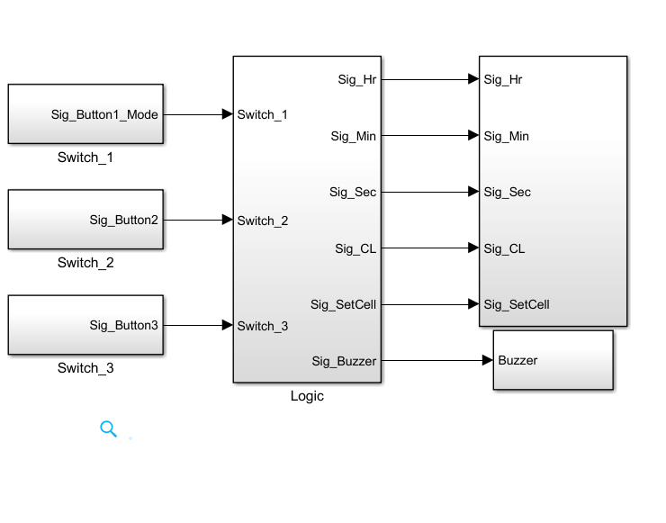

Figure 1 Software Context Diagram

# Input Output Signals

**3.1 Input Output Diagram**

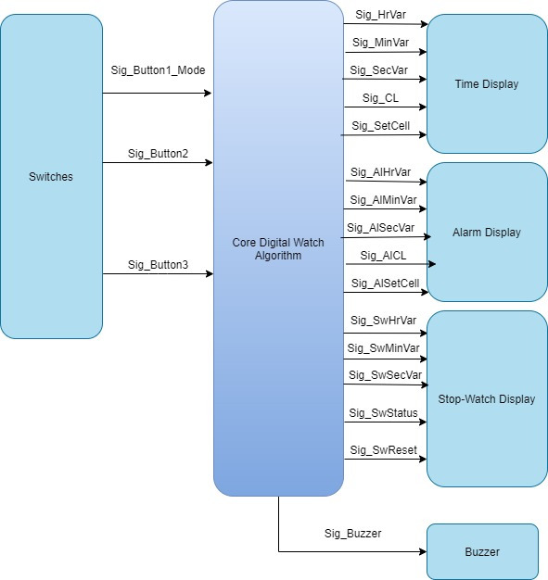

Figure 2 Software Input/output Diagram

**3.2 Input output Table**

|  |  |  |  |  |
| --- | --- | --- | --- | --- |
| **Inputs** | **Name** | **Range** |  | **Unit** |
| Sig_Button1_Mode | 0:2 | NA | |
| Sig_Button2 | 0:1 | NA | |
|  | Sig_Button3 | 0:1 | NA | |
|  | Sig_HrVar | 0:12 | Time-Hours | |
|  | Sig_MinVar | 0:60 | Time-Minutes | |
|  | Sig_SecVar | 0:60 | Time_Seconds | |
|  | Sig_CL | 0:1 | Am/Pm | |
|  | Sig_SetCell | 0:16 | NA | |
|  | Sig_AlHrVar | 0:12 | Time-Hours | |
|  | Sig_AlMinVar | 0:60 | Time-Minutes | |
|  | Sig_AlSecVar | 0:60 | Time-Seconds | |
|  | Sig_AlCL | 0:1 | Am/Pm | |
|  | Sig_AlSetCell | 0:16 | NA | |
|  | Sig_SwHrVar | 0:12 | Time-Hours | |
|  | Sig_SwMinVar | 0:60 | Time-Minutes | |
|  | Sig_SwSecVar | 0:60 | Time-Seconds | |
|  | Sig_Status | 0:1 | NA | |
|  | Sig_Reset | 0:1 | NA | |
|  | Sig_SecVar | 0:60 | Time-Seconds | |
| **Outputs** | **Name** | **Range** | **Unit** | |
|  | Sig_Buzzer | 0:1 | NA | |

# Software Feature:

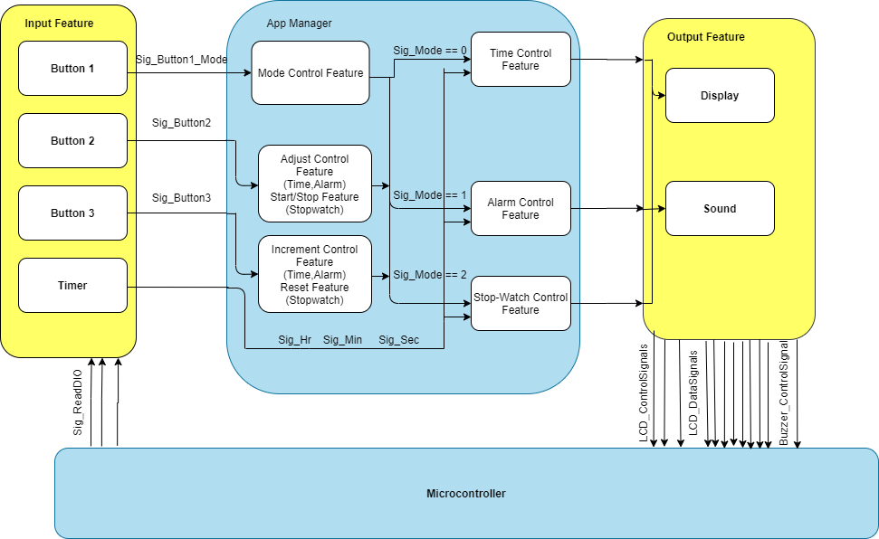

Figure 3 Software Features Diagram

# Static Architecture:

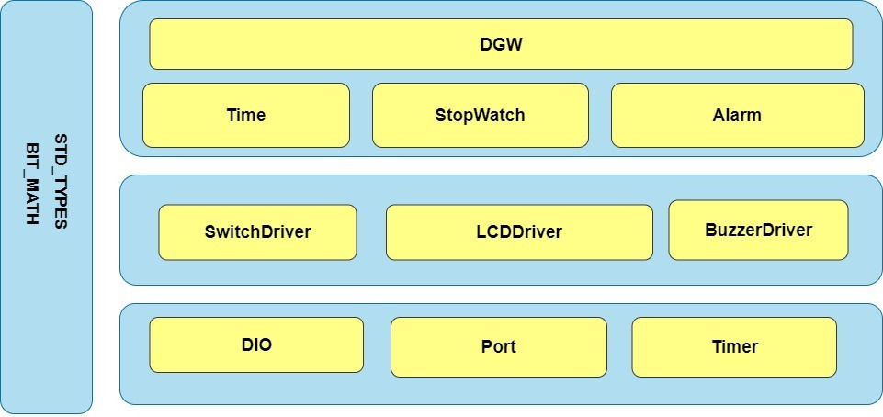

Figure 4 Static Layered Architecture

# 6 Requirements

## **6.1 MCAL Layer:**

## **6.1.1 DIO Component:**

|  |  |  |  |  |  |
| --- | --- | --- | --- | --- | --- |
| **Req_ID** | Req_PO2_DGW_GDD_01_V01.0 | | **Covers** |  | ____________ |
| **Author** | Abdollah Mahmoud | | **Date** | 01/03/2023 | |
| **Description:** | Set Pin Direction for certain Port | | | | |
| **API** | STD_ERORR DIO_SetPinDirection(u8 Copy_u8Port,u8 Copy_u8Pin, u8 Copy_u8Direction) | | | | |
| **Parameters** | **Type** | **Name** | | | **Description** |
| u8  u8  u8 | Copy_u8Port  Copy_u8Pin  Copy_u8Direction | | | Port from ‘A’ to ‘D’ as Ascii code  Pin from 0 to 7  Output -> 1 or input -> 0 |
| **Return** | **Type** | **Name** | | | **Description** |
| STD_ERORR | _____ | | | STD_ERORR  OK -> If sent to the function its valid ranges of port, pin and direction  NOT_OK -> If the ranges sent to the function is out of scope |

|  |  |  |  |  |  |
| --- | --- | --- | --- | --- | --- |
| **Req_ID** | Req_PO2_DGW_GDD_02_V01.0 | | **Covers** |  | __________ |
| **Author** | Abdollah Mahmoud | | **Date** | 01/03/2023 | |
| **Description:** | Set or Reset Pin at certain port | | | | |
| **API** | STD_ERORR DIO_SetPinValue(u8 Copy_u8Port,u8 Copy_u8Pin, u8 Copy_u8Value); | | | | |
| **Parameters** | **Type** | **Name** | | | **Description** |
| u8  u8  u8 | Copy_u8Port  Copy_u8Pin  Copy_u8Value | | | Port from ‘A’ to ‘D’ as Ascii code  Pin from 0 to 7  Value -> 1 to set Pin high  Value -> 0 to set Pin low |
| **Return** | **Type** | **Name** | | | **Description** |
| STD_ERORR | _____ | | | STD_ERORR  OK -> If sent to the function its valid ranges of port, pin and direction  NOT_OK -> If the ranges sent to the function is out of scope |
| **Req_ID** | Req_PO2_DGW_GDD_03_V01.0 | | **Covers** |  | ____________ |
| **Author** | Abdollah Mahmoud | | **Date** | 01/03/2023 | |
| **Description:** | Get Pin value at certain Port  1 -> High  0 -> Low | | | | |
| **API** | STD_ERORR DIO_GetPinVal(u8 Copy_u8Port,u8 Copy_u8Pin,u8* Copy_PtrVal) | | | | |
| **Parameters** | **Type** | **Name** | | | **Description** |
| u8  u8  u8* | Copy_u8Port  Copy_u8Pin  Copy_PtrVal | | | Port from ‘A’ to ‘D’ as Ascii code  Pin from 0 to 7  Pointer to return the status of the pin in it |
| **Return** | **Type** | **Name** | | | **Description** |
| STD_ERORR | _____ | | | STD_ERORR  OK -> If sent to the function its valid ranges of port, pin and direction  NOT_OK -> If the ranges sent to the function is out of scope |

### **6.1.2 Port Component:**

|  |  |  |  |  |  |
| --- | --- | --- | --- | --- | --- |
| **Req_ID** | Req_PO2_DGW_GDD_04_V01.0 | | **Covers** |  | ___________ |
| **Author** | Abdollah Mahmoud | | **Date** | 01/03/2023 | |
| **Description:** | It initialize each Port and Pins to be output or input according to Port_config file  Output -> 1 Input -> 0 | | | | |
| **API** | STD_ERORR Port_Initialize(void); | | | | |
| **Parameters** | **Type** | **Name** | | | **Description** |
| void | _____ | | | _____ |
| **Return** | **Type** | **Name** | | | **Description** |
| STD_ERORR | _____ | | | STD_ERORR  OK -> If the Pins are Initialized Successfully  NOT_OK -> If a problem occurred while initializing any pin |

### **6.1.3 Timer Component:**

|  |  |  |  |  |  |
| --- | --- | --- | --- | --- | --- |
| **Req_ID** | Req_PO2_DGW_GDD_05_V01.0 | | **Covers** |  | Req_PO2_DGW_SRS_01_V01.0  Req_PO2_DGW_SRS_02_V01.0  Req_PO2_DGW_SRS_20_V01.0 |
| **Author** | Abdollah Mahmoud | | **Date** | 01/3/2023 | |
| **Description:** | It makes Timer start to increment. | | | | |
| **API** | STD_ERORR Timer_Init(void) | | | | |
| **Parameters** | **Type** | **Name** | | | **Description** |
| void | _____ | | | _____ |
| **Return** | **Type** | **Name** | | | **Description** |
| STD_ERORR | _____ | | | STD_ERORR  OK -> If the timer initialization is done successfully  NOT_OK -> If any problem occurred while initializing the timer |

|  |  |  |  |  |  |
| --- | --- | --- | --- | --- | --- |
| **Req_ID** | Req_PO2_DGW_GDD_06_V01.0 | | **Covers** |  | Req_PO2_DGW_SRS_01_V01.0  Req_PO2_DGW_SRS_02_V01.0  Req_PO2_DGW_SRS_20_V01.0 |
| **Author** | Abdollah Mahmoud | | **Date** | 01/03/2023 | |
| **Description:** | It will display HrVar, MinVar, Secvar and CycleLength  And it will take which cell to display onto the LCD the it called LCD  to write these data onto this location. | | | | |
| **API** | STD_ERORR Timer_SetCallBack(void(*Copy_pvCallBackPtr)(void)) | | | | |
| **Parameters** | **Type** | **Name** | | | **Description** |
| void (*) (void) | Copy_pvCallBackPtr | | | Pointer to function that it will be implemented when Interrupt has been happened. |
| **Return** | **Type** | **Name** | | | **Description** |
| STD_ERORR | _____ | | | STD_ERORR  OK -> If a function is sent to the callback  NOT_OK -> If anything except a function is sent to the callback |

## **6.2 HAL Layer:**

# 6.2.1 Switch Component:

|  |  |  |  |  |  |
| --- | --- | --- | --- | --- | --- |
| **Req_ID** | Req_PO2_DGW_GDD_07_V01.0 | | **Covers** |  | Req_PO2_DGW_SRS_09_V01.0  Req_PO2_DGW_SRS_10_V01.0  Req_PO2_DGW_SRS_14_V01.0  Req_PO2_DGW_SRS_21_V01.0  Req_PO2_DGW_SRS_23_V01.0  Req_PO2_DGW_SRS_24_V01.0  Req_PO2_DGW_SRS_25_V01.0 |
| **Author** | Abdollah Mahmoud | | **Date** | 01/3/2023 | |
| **Description:** | Get Switch state according to its config file that it configures its Port and pin to get its status | | | | |
| **API** | STD_ERORR Switch_GetState (u8 Copy_u8SwNum,u8* Copy_ptrState) | | | | |
| **Parameters** | **Type** | **Name** | | | **Description** |
| u8  u8* | Copy_u8SwNum  Copy_ptrState | | | Switch Number to get state of a certain switch  Pointer to state of the switch according to Switch_config file  Pressed will represent 0 or 1  If RELEASE_STATE defined as 1  So pressed will represent 0  If RELEASE_STATE defined as 0  So pressed will represent 1 |
| **Return** | **Type** | **Name** | | | **Description** |
| STD_ERORR | _____ | | | STD_ERORR  OK -> If the SwNum sent is in the scope  NOT_OK -> If SwNum sent is out of the scope |

# 6.2.2 Buzzer Component:

|  |  |  |  |  |  |
| --- | --- | --- | --- | --- | --- |
| **Req_ID** | Req_PO2_DGW_GDD_08_V01.0 | | **Covers** |  | Req_PO2_DGW_SRS_03_V01.0  Req_PO2_DGW_SRS_04_V01.0 |
| **Author** | Saher Ghanem | | **Date** | 03/3/2023 | |
| **Description:** | It sets buzzer state according to its config file that it congiures its port and pin. | | | | |
| **API** | STD_ERORR Buzzer_SetState(u8 State) | | | | |
| **Parameters** | **Type** | **Name** | | | **Description** |
| u8 | State | | | Buzzer state to set its pin to this state  High -> 1  Low -> 0 |
| **Return** | **Type** | **Name** | | | **Description** |
| STD_ERORR | _____ | | | STD_ERORR  OK -> If State Sent is 0 or 1  NOT_OK -> If State send is not 0 nor 1 |

# 6.2.3 LCD Component:

|  |  |  |  |  |  |
| --- | --- | --- | --- | --- | --- |
| **Req_ID** | Req_PO2_DGW_GDD_09_V01.0 | | **Covers** |  | Req_PO2_DGW_SRS_06_V01.0  Req_PO2_DGW_SRS_08_V01.0 |
| **Author** | Saher Ghanem | | **Date** | 03/3/2023 | |
| **Description:** | It clears the screen. | | | | |
| **API** | STD_ERORR CLCD_Clear(void) | | | | |
| **Parameters** | **Type** | **Name** | | | **Description** |
| void | _____ | | | _____ |
| **Return** | **Type** | **Name** | | | **Description** |
| STD_ERORR | _____ | | | STD_ERORR  OK -> If the function cleared the LCD successfully  NOT_OK -> If any problem occurred while clearing the LCD |

|  |  |  |  |  |  |
| --- | --- | --- | --- | --- | --- |
| **Req_ID** | Req_PO2_DGW_GDD_10_V01.0 | | **Covers** |  | Req_PO2_DGW_SRS_06_V01.0  Req_PO2_DGW_SRS_08_V01.0 |
| **Author** | Saher Ghanem | | **Date** | 03/3/2023 | |
| **Description:** | It takes Pointer to char of the string that it will be written as whole onto the LCD. | | | | |
| **API** | STD_ERORR CLCD_WriteString(const char* Copy_pchString); | | | | |
| **Parameters** | **Type** | **Name** | | | **Description** |
| const char* | Copy_pchString | | | Pointer to char of the string to be written onto LCD |
| **Return** | **Type** | **Name** | | | **Description** |
| STD_ERORR | _____ | | | STD_ERORR  OK -> If sent character pattern valid in the CGROM  NOT_OK -> If a pattern sent outside the scope of the CGROM |

|  |  |  |  |  |  |
| --- | --- | --- | --- | --- | --- |
| **Req_ID** | Req_PO2_DGW_GDD_11_V01.0 | | **Covers** |  | Req_PO2_DGW_SRS_10_V01  Req_PO2_DGW_SRS_11_V01.0  Req_PO2_DGW_SRS_12_V01.0  Req_PO2_DGW_SRS_13_V01.0  Req_PO2_DGW_SRS_15_V01.0  Req_PO2_DGW_SRS_16_V01.0  Req_PO2_DGW_SRS_17_V01.0  Req_PO2_DGW_SRS_18_V01.0 |
| **Author** | Saher Ghanem | | **Date** | 03/3/2023 | |
| **Description:** | It sets new position for the LCD to start write from.  XPos -> which column  YPos -> which Row  To select which cell. | | | | |
| **API** | STD_ERORR CLCD_GoToXYPos(u8 Copy_u8XPos,u8 Copy_u8YPos); | | | | |
| **Parameters** | **Type** | **Name** | | | **Description** |
| u8  u8 | Copy_u8XPos  Copy_u8YPos | | | XPos -> which column  YPos -> which row |
| **Return** | **Type** | **Name** | | | **Description** |
| STD_ERORR | _____ | | | STD_ERORR  OK -> If XPos is sent between 0-15 and YPos is sent between 0-1  NOT_OK -> If any other range is sent either in XPos or YPos |

|  |  |  |  |  |  |
| --- | --- | --- | --- | --- | --- |
| **Req_ID** | Req_PO2_DGW_GDD_12_V01.0 | | **Covers** |  | Req_PO2_DGW_SRS_06_V01.0  Req_PO2_DGW_SRS_08_V01.0 |
| **Author** | Rasha Saad | | **Date** | 04/3/2023 | |
| **Description:** | It writes number onto the LCD. | | | | |
| **API** | STD_ERORR CLCD_WriteNum (u32 Copy_u32Num); | | | | |
| **Parameters** | **Type** | **Name** | | | **Description** |
| u32 | Copy_u32Num | | | Number to be written onto the LCD |
| **Return** | **Type** | **Name** | | | **Description** |
| STD_ERORR | _____ | | | STD_ERORR  OK -> If Numbers between 0-9 are sent  NOT_OK -> If anything except 0-9 is sent to the function |

## **6.3** **APP Layer**

## **6.3.1 Time-Display Component**

|  |  |  |  |  |  |
| --- | --- | --- | --- | --- | --- |
| **Req_ID** | Req_PO2_DGW_GDD_13_V01.0 | | **Covers** |  | Req_PO2_DGW_SRS_02_V01.0  Req_PO2_DGW_SRS_10_V01.0  Req_PO2_DGW_SRS_14_V01.0 |
| **Author** | Rasha Saad | | **Date** | 04/3/2023 | |
| **Description:** | It displays HrVar, MinVar, Secvar and CycleLength  And it takes which cell to display onto the LCD. | | | | |
| **API** | STD_ERORR Time_Display(u8* Copy_Pu8SetCell) | | | | |
| **Parameters** | **Type** | **Name** | | | **Description** |
| u8* | Copy_Pu8SetCell | | | Certain Position to start write from onto the LCD |
| **Return** | **Type** | **Name** | | | **Description** |
| STD_ERORR | _____ | | | STD_ERORR  OK -> If a valid SetCell between 0-15 is sent  NOT_OK -> If anything is sent in SetCell except 0-15 |

|  |  |  |  |  |  |
| --- | --- | --- | --- | --- | --- |
| **Req_ID** | Req_PO2_DGW_GDD_14_V01.0 | | **Covers** |  | Req_PO2_DGW_SRS_11_V01.0  Req_PO2_DGW_SRS_12_V01.0  Req_PO2_DGW_SRS_13_V01.0 |
| **Author** | Rasha Saad | | **Date** | 04/3/2023 | |
| **Description:** | It adjusts the cursor position at LCD. | | | | |
| **API** | STD_ERORR Time_AdjustCursor (u8* Copy_Pu8SetCell) | | | | |
| **Parameters** | **Type** | **Name** | | | **Description** |
| u8* | Copy_Pu8SetCell | | | Pointer to Certain Position |
| **Return** | **Type** | **Name** | | | **Description** |
| STD_ERORR | _____ | | | STD_ERORR  OK -> If a valid SetCell between 0-15 is sent  NOT_OK -> If anything is sent in SetCell except 0-15 |

|  |  |  |  |  |  |
| --- | --- | --- | --- | --- | --- |
| **Req_ID** | Req_PO2_DGW_GDD_15_V01.0 | | **Covers** |  | Req_PO2_DGW_SRS_14_V01.0 |
| **Author** | Yousef Ahmed | | **Date** | 06/3/2023 | |
| **Description:** | It increments Hrvar, SecVar and MinVar according to which cell LCD on at this time. | | | | |
| **API** | STD_ERORR Time_Incr(u8* Copy_Pu8SetCell) | | | | |
| **Parameters** | **Type** | **Name** | | | **Description** |
| u8* | Copy_Pu8SetCell | | | Pointer to Certain Position |
| **Return** | **Type** | **Name** | | | **Description** |
| STD_ERORR | _____ | | | STD_ERORR  OK -> If a valid SetCell between 0-15 is sent  NOT_OK -> If anything is sent in SetCell except 0-15 |

## **6.3.2 Alarm mode requirements**

|  |  |  |  |  |  |
| --- | --- | --- | --- | --- | --- |
| **Req_ID** | Req_PO2_DGW_GDD_16_V01.0 | | **Covers** |  | Req_PO2_DGW_SRS_15_V01.0  Req_PO2_DGW_SRS_16_V01.0  Req_PO2_DGW_SRS_17_V01.0  Req_PO2_DGW_SRS_18_V01.0  Req_PO2_DGW_SRS_19_V01.0 |
| **Author** | Yousef Ahmed | | **Date** | 06/3/2023 | |
| **Description:** | It displays AlHrVar, AlMinVar, AlSecvar and AlCycleLength  And it takes which cell to display onto the LCD. | | | | |
| **API** | STD_ERORR Alarm_Display(u8* Copy_Pu8SetCell) | | | | |
| **Parameters** | **Type** | **Name** | | | **Description** |
| u8* | Copy_Pu8SetCell | | | Certain Position to start write from onto the LCD |
| **Return** | **Type** | **Name** | | | **Description** |
| STD_ERORR | _____ | | | STD_ERORR  OK -> If a valid SetCell between 0-15 is sent  NOT_OK -> If anything is sent in SetCell except 0-15 |

|  |  |  |  |  |  |
| --- | --- | --- | --- | --- | --- |
| **Req_ID** | Req_PO2_DGW_GDD_17_V01.0 | | **Covers** |  | Req_PO2_DGW_SRS_15_V01.0  Req_PO2_DGW_SRS_16_V01.0  Req_PO2_DGW_SRS_17_V01.0  Req_PO2_DGW_SRS_18_V01.0 |
| **Author** | Yousef Ahmed | | **Date** | 06/3/2023 | |
| **Description:** | It adjusts the cursor position at LCD. | | | | |
| **API** | STD_ERORR Alarm_AdjustCursor (u8* Copy_Pu8SetCell) | | | | |
| **Parameters** | **Type** | **Name** | | | **Description** |
| u8* | Copy_Pu8SetCell | | | Pointer to Certain Position |
| **Return** | **Type** | **Name** | | | **Description** |
| STD_ERORR | _____ | | | STD_ERORR  OK -> If a valid SetCell between 0-15 is sent  NOT_OK -> If anything is sent in SetCell except 0-15 |
| **Req_ID** | Req_PO2_DGW_GDD_18_V01.0 | | **Covers** |  | Req_PO2_DGW_SRS_19_V01.0 |
| **Author** | Mohamed Maghraby | | **Date** | 06/3/2023 | |
| **Description:** | It increments AlHrvar, AlSecVar and AlMinVar according to which cell LCD on at this time. | | | | |
| **API** | STD_ERORR Alarm_Incr(u8* Copy_Pu8SetCell) | | | | |
| **Parameters** | **Type** | **Name** | | | **Description** |
| u8* | Copy_Pu8SetCell | | | Pointer to Certain Position |
| **Return** | **Type** | **Name** | | | **Description** |
| STD_ERORR | _____ | | | STD_ERORR  OK -> If a valid SetCell between 0-15 is sent  NOT_OK -> If anything is sent in SetCell except 0-15 |

### 6.3.3 Stop-Watch Component

|  |  |  |  |  |  |
| --- | --- | --- | --- | --- | --- |
| **Req_ID** | Req_PO2_DGW_GDD_19_V01.0 | | **Covers** |  | Req_PO2_DGW_SRS_22_V01.0  Req_PO2_DGW_SRS_23_V01.0 |
| **Author** | Mohamed Maghraby | | **Date** | 09/3/2023 | |
| **Description:** | It displays StHrVar, StMinVar, StSecvar.  And it takes which cell to display onto the LCD. | | | | |
| **API** | STD_ERORR SW_Display(void) | | | | |
| **Parameters** | **Type** | **Name** | | | **Description** |
| void | _____ | | | _____ |
| **Return** | **Type** | **Name** | | | **Description** |
| STD_ERORR | _____ | | | STD_ERORR  OK -> If variables of StopWatch are displayed successfully on the LCD  NOT_OK -> If a problem occurred while displaying the StopWath Variables on the LCD |
| **Req_ID** | Req_PO2_DGW_GDD_20_V01.0 | | **Covers** |  | Req_PO2_DGW_SRS_21_V01.0  Req_PO2_DGW_SRS_22_V01.0  Req_PO2_DGW_SRS_23_V01.0  Req_PO2_DGW_SRS_24_V01.0 |
| **Author** | Mohamed Maghraby | | **Date** | 09/3/2023 | |
| **Description:** | It checks which press at this time  First press -> start SW -> Set SW_flag = 1 to start increment  Second press -> Stop SW -> Stopwatch_flag = 1 to reset  Thirs press -> Resume SW_flag = 0 | | | | |
| **API** | STD_ERORR SW_CheckStatus(void) | | | | |
| **Parameters** | **Type** | **Name** | | | **Description** |
| void | _____ | | | _____ |
| **Return** | **Type** | **Name** | | | **Description** |
| STD_ERORR | _____ | | | STD_ERORR  OK -> If SW_Flag is within its range  NOT_OK -> If SW_Flag overflowed its range |

|  |  |  |  |  |  |
| --- | --- | --- | --- | --- | --- |
| **Req_ID** | Req_PO2_DGW_GDD_20_V01.0 | | **Covers** |  | Req_PO2_DGW_SRS_25_V01.0  Req_PO2_DGW_SRS_26_V01.0 |
| **Author** | Samira Saeid | | **Date** | 09/3/2023 | |
| **Description:** | It Resets SW_flag and StopWatch_flag | | | | |
| **API** | STD_ERORR SW_Reset(void) | | | | |
| **Parameters** | **Type** | **Name** | | | **Description** |
| void | _____ | | | _____ |
| **Return** | **Type** | **Name** | | | **Description** |
| STD_ERORR | _____ | | | STD_ERORR  OK -> If StopWatch Variables are set to zeros Successfully  NOT_OK -> If a problem occurred while setting the StopWatch Variables to Zeros |

## **6.3.4 DGW Requirements**

|  |  |  |  |  |  |
| --- | --- | --- | --- | --- | --- |
| **Req_ID** | Req_PO2_DGW_GDD_21_V01.0 | | **Covers** |  | Req_PO2_DGW_SRS_06_V01.0  Req_PO2_DGW_SRS_09_V01.0  Req_PO2_DGW_SRS_10_V01.0  Req_PO2_DGW_SRS_21_V01.0  Req_PO2_DGW_SRS_23_V01.0  Req_PO2_DGW_SRS_25_V01.0 |
| **Author** | Samira Saeid | | **Date** | 09/3/2023 | |
| **Description:** | It reads Button 1 switch state and modifies Current_Mode(Global Variable) signal to detect which mode is running know (Time or Alarm or Stop Watch) | | | | |
| **API** | STD_ERORR ReadMode(void) | | | | |
| **Parameters** | **Type** | **Name** | | | **Description** |
| void | _____ | | | _____ |
| **Return** | **Type** | **Name** | | | **Description** |
| STD_ERORR | _____ | | | STD_ERORR  OK -> If current mode is within its range 0-2  NOT_OK -> If current mode overflowed its range |

|  |  |  |  |  |  |
| --- | --- | --- | --- | --- | --- |
| **Req_ID** | Req_PO2_DGW_GDD_22_V01.0 | | **Covers** |  | Req_PO2_DGW_SRS_02_V01.0  Req_PO2_DGW_SRS_06_V01.0  Req_PO2_DGW_SRS_07_V01.0  Req_PO2_DGW_SRS_10_V01.0 |
| **Author** | Samira Saeid | | **Date** | 09/3/2023 | |
| **Description:** | It checks Current_Mode signal to choice which to display -> Time/Alarm/Stopwatch  Current_Mode is a global variable. | | | | |
| **API** | STD_ERORR Display(void) | | | | |
| **Parameters** | **Type** | **Name** | | | **Description** |
| void | _____ | | | _____ |
| **Return** | **Type** | **Name** | | | **Description** |
| STD_ERORR | _____ | | | STD_ERORR  OK -> If current mode is within its range 0-2  NOT_OK -> If current mode overflowed its range |
| **Req_ID** | Req_PO2_DGW_GDD_23_V01.0 | | **Covers** |  | Req_PO2_DGW_SRS_11_V01.0  Req_PO2_DGW_SRS_12_V01.0  Req_PO2_DGW_SRS_13_V01.0  Req_PO2_DGW_SRS_15_V01.0  Req_PO2_DGW_SRS_16_V01.0  Req_PO2_DGW_SRS_17_V01.0  Req_PO2_DGW_SRS_18_V01.0 |
| **Author** | Samira Saeid | | **Date** | 09/3/2023 | |
| **Description:** | It reads Button 2 switch state  If (Pressed) -> Check Current_Mode signal to detect which mode is running know.  If (Current_Mode == 0) -> call Time_voidAdjustCursor()  If (Current_Mode == 1) -> call Alarm_voidAdjustCursor()  If (Current_Mode == 2) -> call SW_voidCheckstatus()  Current_Mode is a global variable. | | | | |
| **API** | STD_ERORR ReadPos(void) | | | | |
| **Parameters** | **Type** | **Name** | | | **Description** |
| void | _____ | | | _____ |
| **Return** | **Type** | **Name** | | | **Description** |
| STD_ERORR | _____ | | | STD_ERORR  OK -> If current mode is within its range 0-2  NOT_OK -> If current mode overflowed its range |

|  |  |  |  |  |  |
| --- | --- | --- | --- | --- | --- |
| **Req_ID** | Req_PO2_DGW_GDD_24_V01.0 | | **Covers** |  | Req_PO2_DGW_SRS_14_V01.0  Req_PO2_DGW_SRS_19_V01.0 |
| **Author** | Samira Saeid | | **Date** | 09/3/2023 | |
| **Description:** | It reads Button 3 switch state  If (Pressed) -> Check Current_Mode signal to detect which mode is running know.  If (Current_Mode == 0) -> call Time_voidIncr()  If (Current_Mode == 1) -> call Time_voidIncr()  If (Current_Mode == 2) -> call SW_voidReset()  Current_Mode is a global variable. | | | | |
| **API** | STD_ERORR ReadInc(void) | | | | |
| **Parameters** | **Type** | **Name** | | | **Description** |
| void | _____ | | | _____ |
| **Return** | **Type** | **Name** | | | **Description** |
| STD_ERORR | _____ | | | STD_ERORR  OK -> If current mode is within its range 0-2  NOT_OK -> If current mode overflowed its range |

|  |  |  |  |  |  |
| --- | --- | --- | --- | --- | --- |
| **Req_ID** | Req_PO2_DGW_GDD_25_V01.0 | | **Covers** |  | Req_PO2_DGW_SRS_20_V01.0 |
| **Author** | Samuel Medhat | | **Date** | 11/3/2023 | |
| **Description:** | It checks Buzzer_signal  If (Buzzer_signal ) -> turn Buzzer on  If (Buzzer_signal) -> turn Buzzer off  Buzzer_signal is a global variable. | | | | |
| **API** | STD_ERORR CheckBuzzerState(void) | | | | |
| **Parameters** | **Type** | **Name** | | | **Description** |
| void | _____ | | | _____ |
| **Return** | **Type** | **Name** | | | **Description** |
| STD_ERORR | _____ | | | STD_ERORR  OK -> If buzzer set at 1 and reset at 0  NOT_OK -> If undefined behavior occurs regarding the buzzer |

|  |  |  |  |  |  |
| --- | --- | --- | --- | --- | --- |
| **Req_ID** | Req_PO2_DGW_GDD_26_V01.0 | | **Covers** |  | Req_PO2_DGW_SRS_01_V01.0  Req_PO2_DGW_SRS_02_V01.0  Req_PO2_DGW_SRS_03_V01.0 |
| **Author** | Samuel Medhat | | **Date** | 17/03/2023 | |
| **Description:** | It increments HrVar, MinVar and SecVar every 1 sec by passing this function to the ISR of the timer.  And it checks Current_Mode signal  If(Current_Mode == 1) -> Alarm Mode  So if (HrVar,MinVar and SecVar == AlHrVar, AlMinVar and AlSecVar )  Buzzer_signal = 1 | | | | |
| **API** | STD_ERORR TimeInc(void) | | | | |
| **Parameters** | **Type** | **Name** | | | **Description** |
| void | _____ | | | _____ |
| **Return** | **Type** | **Name** | | | **Description** |
| STD_ERORR | _____ | | | STD_ERORR  OK -> If current mode is within its range 0-2  NOT_OK -> If current mode overflowed its range |

|  |  |  |  |  |  |
| --- | --- | --- | --- | --- | --- |
| **Req_ID** | Req_PO3_DGW_GDD_24_V01.0 | | **Covers** |  | Req_PO3_DGW_SRS_14_V01.2  Req_PO3_DGW_SRS_19_V01.2 |
| **Author** | Samuel Medhat | | **Date** | 17/03/2023 | |
| **Description:** | It reads Button 3 switch state  If (Pressed) -> Check Current_Mode signal to detect which mode is running know.  If (Current_Mode == 0) -> call Time_voidIncr()  If (Current_Mode == 1) -> call Time_voidIncr()  If (Current_Mode == 2) -> call SW_voidReset()  Current_Mode is a global variable. | | | | |
| **API** | STD_ERORR ReadInc(void) | | | | |
| **Parameters** | **Type** | **Name** | | | **Description** |
| void | _____ | | | _____ |
| **Return** | **Type** | **Name** | | | **Description** |
| STD_ERORR | _____ | | | STD_ERORR  OK -> If current mode is within its range 0-2  NOT_OK -> If current mode overflowed its range |

|  |  |  |  |  |  |
| --- | --- | --- | --- | --- | --- |
| **Req_ID** | Req_PO3_DGW_GDD_25_V01.0 | | **Covers** |  | Req_PO3_DGW_SRS_20_V01.2 |
| **Author** | Samuel Medhat | | **Date** | 17/03/2023 | |
| **Description:** | It checks Buzzer_signal  If (Buzzer_signal ) -> turn Buzzer on  If (Buzzer_signal) -> turn Buzzer off  Buzzer_signal is a global variable. | | | | |
| **API** | STD_ERORR CheckBuzzerState(void) | | | | |
| **Parameters** | **Type** | **Name** | | | **Description** |
| void | _____ | | | _____ |
| **Return** | **Type** | **Name** | | | **Description** |
| STD_ERORR | _____ | | | STD_ERORR  OK -> If buzzer set at 1 and reset at 0  NOT_OK -> If undefined behavior occurs regarding the buzzer |

|  |  |  |  |  |  |
| --- | --- | --- | --- | --- | --- |
| **Req_ID** | Req_PO3_DGW_GDD_26_V01.0 | | **Covers** |  | Req_PO3_DGW_SRS_01_V01.2  Req_PO3_DGW_SRS_02_V01.2  Req_PO3_DGW_SRS_03_V01.2 |
| **Author** | Samuel Medhat | | **Date** | 17/03/2023 | |
| **Description:** | It increments HrVar, MinVar and SecVar every 1 sec by passing this function to the ISR of the timer.  And it checks Current_Mode signal  If(Current_Mode == 1) -> Alarm Mode  So if (HrVar,MinVar and SecVar == AlHrVar, AlMinVar and AlSecVar )  Buzzer_signal = 1 | | | | |
| **API** | STD_ERORR TimeInc(void) | | | | |
| **Parameters** | **Type** | **Name** | | | **Description** |
| void | _____ | | | _____ |
| **Return** | **Type** | **Name** | | | **Description** |
| STD_ERORR | _____ | | | STD_ERORR  OK -> If current mode is within its range 0-2  NOT_OK -> If current mode overflowed its range |